Nama : Erlangga Rizal Mahendra

NIM : 2440101704

Mo_8

## 1. Create a view named ‘ViewBonus’ to display BinusId (obtained from CustomerID by replacing the first 2 characters with ‘BN ’), and CustomerName for every customer whose name is more than 10 characters.

**(create view**, **stuff**, **len)**

CREATE VIEW ViewBonus AS

SELECT REPLACE(CustomerId, 'CU', 'BN') AS "BinusID", CustomerName

FROM

MsCustomer

WHERE

LEN(CustomerName) > 10;

GO

SELECT * FROM ViewBonus

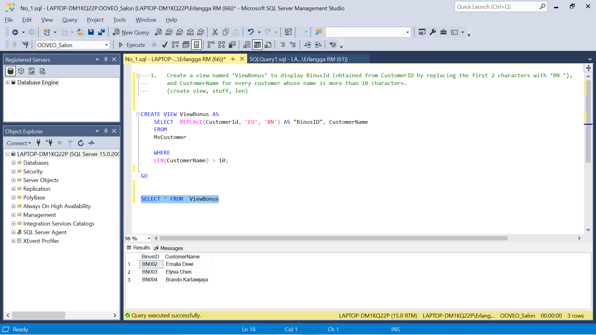

**2.** Create a view named ‘ViewCustomerData’ to display Name (obtained from customer’s name from the first character until a character before space), Address (obtained from CustomerAddress), and Phone (obtained from CustomerPhone) for every customer whose name contains space.

**(create view**, **substring**, **charindex)**

USE OOVEO_Salon

CREATE VIEW ViewCustomerData AS

SELECT

LEFT(CustomerName, CHARINDEX(' ', CustomerName)) AS "Name",

CustomerAddress AS "Address",

CustomerPhone AS Phone

FROM

MsCustomer

WHERE

LEN(CustomerName) - LEN(REPLACE(CustomerName, ' ', '')) > 0;

GO

SELECT * FROM ViewCustomerData

**3.** Create a view named ‘ViewTreatment’ to display TreatmentName, TreatmentTypeName, Price (obtained from Price by adding ‘Rp. ’ in front of Price) for every treatment which type is ‘Hair Treatment’ and price is between 450000 and 800000.

**(create view**, **cast**, **between)**

USE OOVEO_Salon

CREATE VIEW ViewTreatment AS

SELECT

MsTreatment.TreatmentName,

MsTreatmentType.TreatmentTypeName,

'Rp.' + CAST(MsTreatment.Price AS VARCHAR) AS "Price"

FROM

MsTreatment, MsTreatmentType

WHERE

MsTreatmentType.TreatmentTypeId = MsTreatment.TreatmentTypeId

AND

MsTreatmentType.TreatmentTypeName = 'Hair Treatment'

AND

MsTreatment.Price BETWEEN 450000 AND 800000;

**4.** Create a view named ‘ViewTransaction’ to display StaffName, CustomerName, TransactionDate (obtained from TransactionDate in ‘dd mon yyyy’ format), and PaymentType for every transaction which the transaction is between 21st and 25th day and was paid by ‘Credit’.

**(create view**, **convert**, **day**, **between)**

USE OOVEO_Salon

CREATE VIEW ViewTransaction AS

SELECT

MsStaff.StaffName,

MsCustomer.CustomerName,

CONVERT(DATE, HeaderSalonServices.TransactionDate, 106) AS "TransactionDate",

HeaderSalonServices.PaymentType

FROM

MsStaff, MsCustomer, HeaderSalonServices

WHERE

MsCustomer.CustomerId = HeaderSalonServices.CustomerId

AND

MsStaff.StaffId = HeaderSalonServices.StaffId

AND

DAY(HeaderSalonServices.TransactionDate) BETWEEN 21 AND 25

AND

HeaderSalonServices.PaymentType = 'Credit';

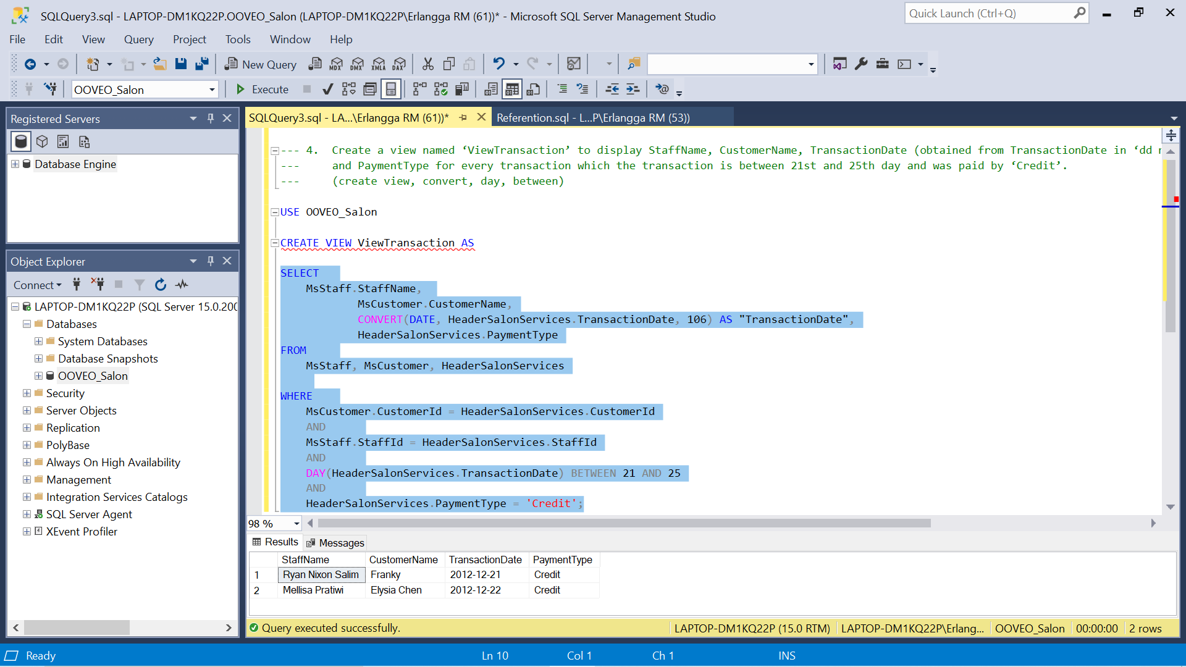

**5.** Create a view named ‘ViewBonusCustomer’ to display BonusId (obtained from CustomerId by replacing ‘CU’ with ‘BN’), Name (Obtained from CustomerName by taking the next character after space until the last character in lower case format), Day (obtained from the day when the transaction happened), and TransactionDate (obtained from TransactionDate in ‘mm/dd/yy’ format) for every transaction which customer’s name contains space and staff’s last name contains ‘a’ character.

**(create view**, **replace**, **lower**, **substring**, **charindex**, **len**, **datename**, **weekday**, **convert**, **like)**

USE OOVEO_Salon

CREATE VIEW ViewBonusCustomer AS

SELECT

REPLACE(MsCustomer.CustomerId, 'CU', 'BN') AS "BonusID",

LOWER(

SUBSTRING(

MsCustomer.CustomerName,

CHARINDEX(' ', MsCustomer.CustomerName) + 1,

LEN(MsCustomer.CustomerName)

)

) AS "Name",

DATENAME(WEEKDAY, HeaderSalonServices.TransactionDate) AS "Day",

CONVERT(DATE, HeaderSalonServices.TransactionDate, 101) AS "TransactionDate"

FROM

MsCustomer, HeaderSalonServices

WHERE

MsCustomer.CustomerId = HeaderSalonServices.CustomerId

AND

LEN(MsCustomer.CustomerName) - LEN(REPLACE(MsCustomer.CustomerName, ' ', '')) > 0

AND

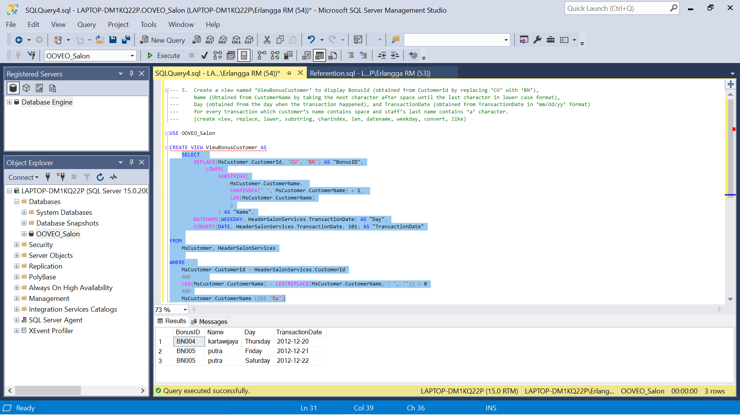 MsCustomer.CustomerName LIKE '%a';

6. Create a view named ‘ViewTransactionByLivia’ to display TransactionId, Date (obtained from TransactionDate in ‘Mon dd, yyyy’ format), and TreatmentName for every transaction which occurred on the 21st day and handled by staff whose name is ‘Livia Ashianti’.

**(create view, convert, day, like)**

USE OOVEO_Salon

CREATE VIEW ViewTransactionByLivia AS

SELECT

HeaderSalonServices.TransactionId,

CONVERT(DATE, HeaderSalonServices.TransactionDate, 107) AS "Date", MsTreatment.TreatmentName

FROM

MsStaff, MsTreatment,

HeaderSalonServices,DetailSalonServices

WHERE

MsStaff.StaffId = HeaderSalonServices.StaffId

AND

MsTreatment.TreatmentId = DetailSalonServices.TreatmentId

AND

DetailSalonServices.TransactionId = HeaderSalonServices.TransactionId

AND

DAY(HeaderSalonServices.TransactionDate) = 21

AND

MsStaff.StaffName LIKE 'Livia Ashianti'

**7.** Change the view named ‘ViewCustomerData’ to ID (obtained from the last 3 digit characters of CustomerID), Name (obtained from CustomerName), Address (obtained from CustomerAddress), and Phone (obtained from CustomerPhone) for every customer whose name contains space.

**(alter view, right, charindex)**

USE OOVEO_Salon

ALTER VIEW ViewCustomerData AS

SELECT

RIGHT(CustomerId, CHARINDEX('U', CustomerId) + 1) AS "ID",

CustomerName AS "Name",

CustomerAddress AS "Address",

CustomerPhone AS "Phone"

FROM

MsCustomer

WHERE

CHARINDEX(' ', CustomerName) > 0

8. Create a view named ‘ViewCustomer’ to display CustomerId, CustomerName, CustomerGender from MsCustomer, then add the data to ViewCustomer with the following specifications:

USE OOVEO_Salon

CREATE VIEW ViewCustomer AS

SELECT * FROM MsCustomer

INSERT INTO ViewCustomer (CustomerId, CustomerName, CustomerGender)

VALUES ('CU006', 'Cristian', 'Male')

SELECT * FROM ViewCustomer

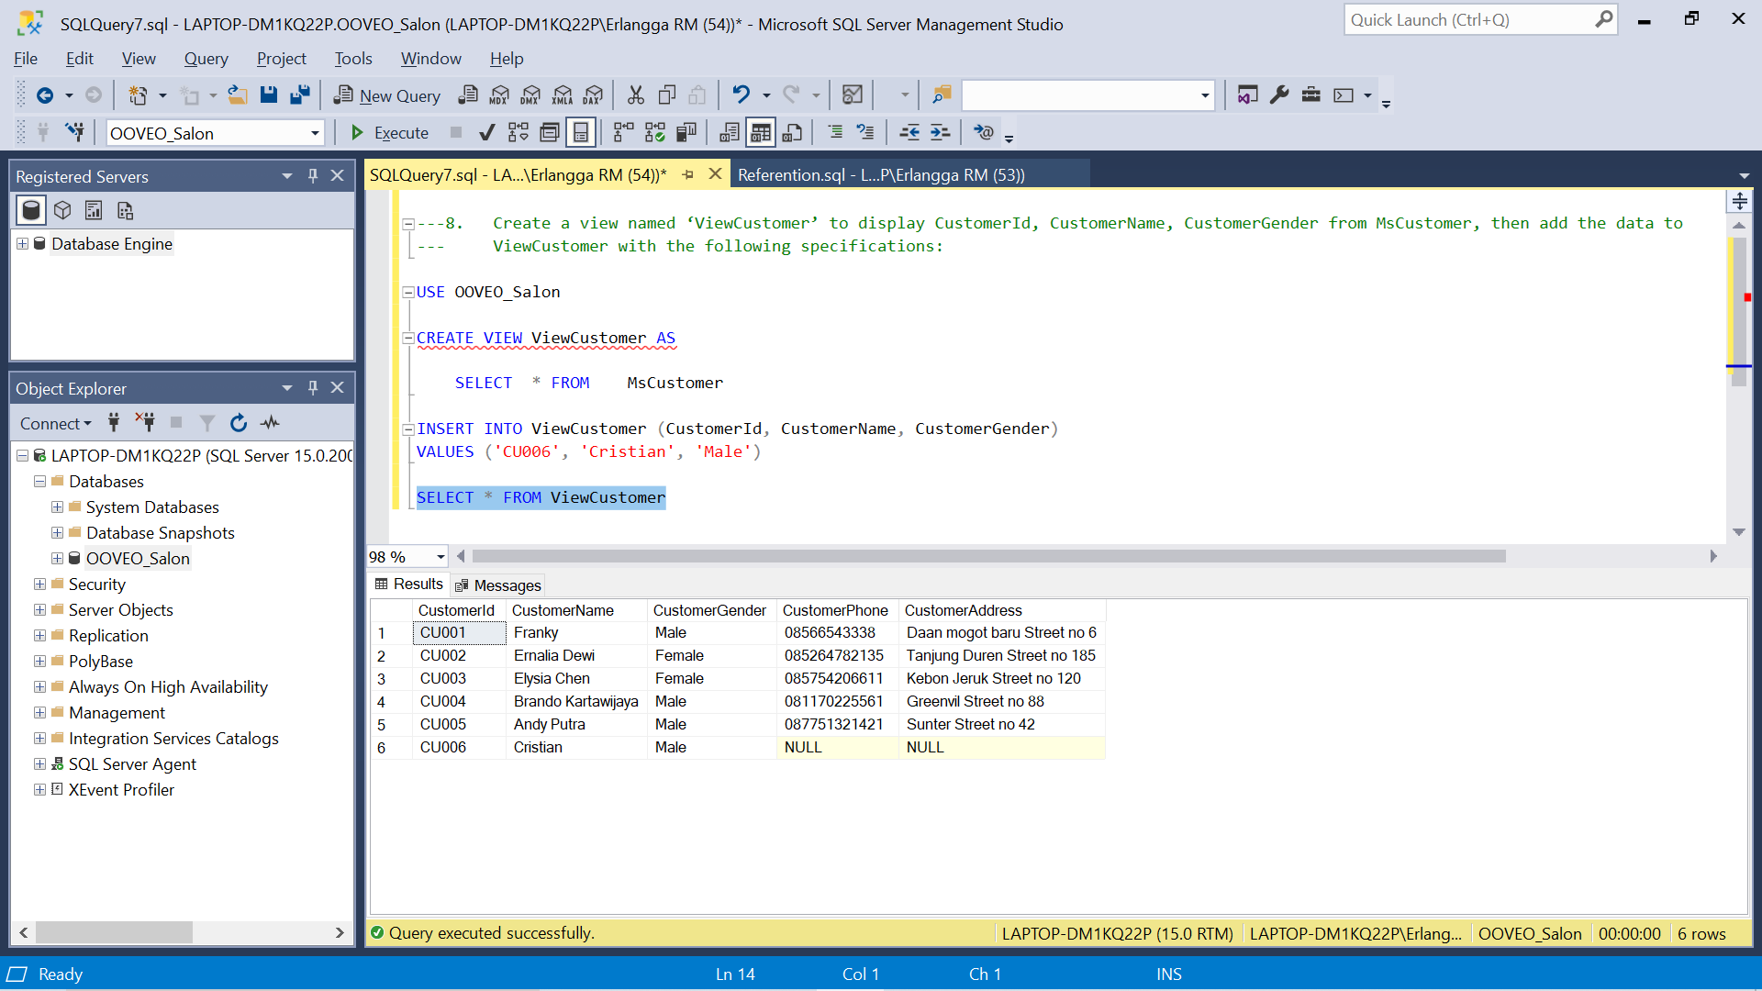

**9.** Delete data in view ‘ViewCustomerData’ that has ID ‘005’. Then display all data from **ViewCustomerData**.

**(delete)**

USE OOVEO_Salon

DELETE FROM ViewCustomerData

WHERE ID = '005';

SELECT * FROM ViewCustomerData

Before Delete

After Delete

**10.** Delete the view named *‘*ViewCustomerData’.

(**drop view**)

USE OOVEO_Salon

DROP VIEW ViewCustomerData;

